TITLE IN CAPS:

SUBTITLE ALSO IN CAPS

A Thesis

presented to

the Faculty of California Polytechnic State University,

San Luis Obispo

In Partial Fulfillment

of the Requirements for the Degree

Master of Science in Mechanical Engineering

by

Samuel Steejans Artho-Bentz

June 16, 2017

[](http://creativecommons.org/licenses/by-nc-sa/4.0/)  
This work is licensed under a [Creative Commons Attribution-NonCommercial-ShareAlike 4.0 International License](http://creativecommons.org/licenses/by-nc-sa/4.0/).

© 2017

Samuel Steejans Artho-Bentz

ALL RIGHTS RESERVED

COMMITTEE MEMBERSHIP

|  |  |  |
| --- | --- | --- |
| TITLE: |  |  |
| AUTHOR: |  | Samuel Steejans Artho-Bentz |
| DATE SUBMITTED: |  | June 16, 2017 |
| COMMITTEE CHAIR |  | John Ridgely, Ph.D.  Professor of Mechanical Engineering |
| COMMITTEE MEMBER: |  | William Murray, Ph.D.  Professor of Mechanical Engineering |
| COMMITTEE MEMBER: |  | Glen Thorncroft, Ph.D.  Professor of Mechanical Engineering |

ABSTRACT

Title

Samuel Steejans Artho-Bentz

Placeholder text… Insert content here.

Keywords:

ACKNOWLEDGMENTS

Placeholder text… Insert content here.

Table of contents

LIST OF FIGURES viii

1. Introduction 10

1.1 Statement of Purpose 10

1.2 Scope of Thesis Project 10

2. Background 11

2.1 State of the Art 11

3. Theory 23

3.1 Coordinate System Definitions 23

3.2 Angles of Interest 24

3.3 Points of Note 27

3.4 Home Position 28

3.5 Transformations 30

3.6 Angular Velocities 33

3.7 Pointing a telescope 34

4. Design 35

4.1 State of Previous System 35

4.2 Design Guidelines 40

4.3 Electrical Modifications 44

4.4 Software Modifications 48

5. Testing and Verification 51

5.1 Testing Set Up 51

5.2 Test Descriptions 52

6. Conclusion 65

6.1 Rotators 65

6.2 Linear Actuators 65

6.3 Control Feedback 65

7. Bibliography 66

Appendix A - Doxygen Manual 68

Appendix B Drawings of any parts I made 69

Appendix C 70

LIST OF FIGURES

Figure 1: Definition of Altitude/Azimuth relative to an observer 12

Figure 2: Altitude Azimuth mount used for satellite tracking in the 1960s 13

Figure 3: 10" Telescope on an Altitude Azimuth Mount 14

Figure 4: Vixen GP-DX German equatorial mount 15

Figure 5: Zeiss Telescope at the Merate Astronomical Observatory. Mounted on an equatorial mount 16

Figure 6: Stewart-Gough Platform in use 18

Figure 7: AMiBA in neutral position. 19

Figure 8: Solid model showing the design of the Parallel Actuator Mount prototype 21

Figure 9: XYZ Coordinate system. 23

Figure 10: X'Y'Z' Coordinate System 24

Figure 11: Definition of the Positive Azimuth Angle 25

Figure 12: Definition of the Positive Altitude Angle 26

Figure 13: Definition of the Positive Image Rotation Angle 27

Figure 14: Points of Note 28

Figure 15: Parallel Actuator Mount in home position 29

Figure 16: Original Linear Actuator 35

Figure 17: Ground to Actuator Rotator Assembly 36

Figure 18: Actuator to Telescope Rotator Assembly 37

Figure 19: Telescope Rotator Assembly 38

Figure 20: Mbed LPC1768 Prototype board with custom motor driver board installed 39

Figure 21: Secondary electronics for control of telescope's focusing mirror 39

Figure 22: Stepper Motor Assembly 41

Figure 23: Fully Assembled Electronics Stack 45

Figure 24: ST Nucleo L476RG 46

Figure 25: ST L6470 Stepper Motor Driver 47

Figure 26: Shoe of Brian Custom PCB 48

Figure 27: Laser diodes mounted for testing 51

Figure 28: Relative Rotation Test 53

Figure 29: Altitude Relative Position Test 55

Figure 30: Altitude Relative Position Test. Azimuth = 0° 57

Figure 31: Altitude Relative Position Test. Azimuth = 0° 58

Figure 32: Altitude Repeatability Test 60

Figure 33: Complex Repeatability Test 2A 61

Figure 34: Complex Repeatability Test 2B 62

Figure 35: Complex Repeatability Test 2C 63

Figure 36: Long Run Repeatability Test Setup 64

Figure 37: Long Run Repeatability Test Close View of Results 64

# Introduction

## Statement of Purpose

A previous thesis at California Polytechnic State University, San Luis Obispo (Gudgel, 2015) demonstrated the feasibility of a three degree-of-freedom parallel actuator telescope mount based loosely on the six degree-of-freedom Array for Microwave Background Anisotropy (AMiBA) telescope. The shorter load paths created by the parallel actuators result in a stiff, light system with a high natural frequency, which is good for accurate pointing. This simplified mount sacrifices full sky coverage for portability, and lower cost. The purpose of this thesis is to refine the proof-of-concept developed at Cal Poly with commonly available, lower priced components and to develop code which can be utilized by universities and astronomers to create their own parallel actuator telescope mounts.

## Scope of Thesis Project

The goal of this thesis is to build upon the partial proof-of-concept prototype in order to demonstrate the capability of the system to accurately point at and track stars. This includes improvements to the mechanical, electrical, and control system. A focus will be on the simplification of the system, cost saving, and the use of off-the-shelf parts in order to increase the feasibility of the design for educational and hobbyist use.

# Background

## State of the Art

Telescope mounts have three angles of interest which are used to describe where the telescope is pointed and the orientation of the telescope towards that point. These three angles can be defined in various ways. The most easily applied definition for telescope aiming is altitude-azimuth-image rotation. This set of angles is defined for a local observer. Altitude is the angle above the horizon. Azimuth is the angle about an axis perpendicular to Earth’s surface starting from some reference point, generally north or south, see Figure 1: Definition of Altitude/Azimuth relative to an observer

(TWCarlson). The third angle, which is not a controlled angle in all mounting systems, is the rotation about the axis at which the telescope is pointing. This last angle can be important in astronomy especially to create a reference. It is critical to binary star position measurements which refer to celestial North for measurement (Ridgely). Controlling the third angle also allows for longer exposure photographs to be taken by keeping the viewing angle of the object constant. Although this set of angles is convenient for aiming a telescope from a specific place and time, another coordinate system, Right Ascension-Declination, is used as the more general celestial coordinates given in books and tables of celestial bodies because it is independent of time and location. It is possible to convert from Right Ascension-Declination to Alitude-Azimuth as shown in Section 3.7.



Figure : Definition of Altitude/Azimuth relative to an observer

(TWCarlson)

### Traditional Telescope Mounts

Traditional telescope mounts generally use one actuator per angle of interest. These actuators are necessarily mounted in series such that each actuator must hold the entire weight of the telescope as well as that of each actuator above it. This results in large required actuation strength as well as massive systems to get the required stiffness.

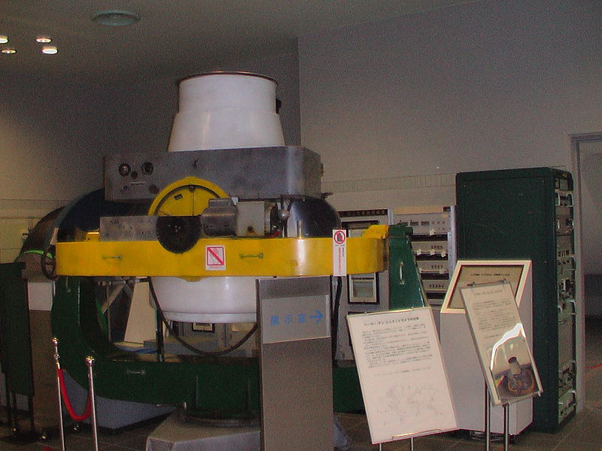

Figure : Altitude Azimuth mount used for satellite tracking in the 1960s

(Baker-Nunn Camera, 2009)



Figure : 10" Telescope on an Altitude Azimuth Mount

(Dobson Mount, 2005)

The most basic mount, referred to as an altitude azimuth mount, see Figure 2 and Figure 3, has a rotational actuator which directly moves the azimuth angle. On top of that, is a second actuator which controls the altitude angle. The altitude azimuth mount generally has no way to directly control the image rotation angle and requires that functionality to be built into the telescope itself through means of an image derotation device.



Figure : Vixen GP-DX German equatorial mount

(Nguyen, 2007)

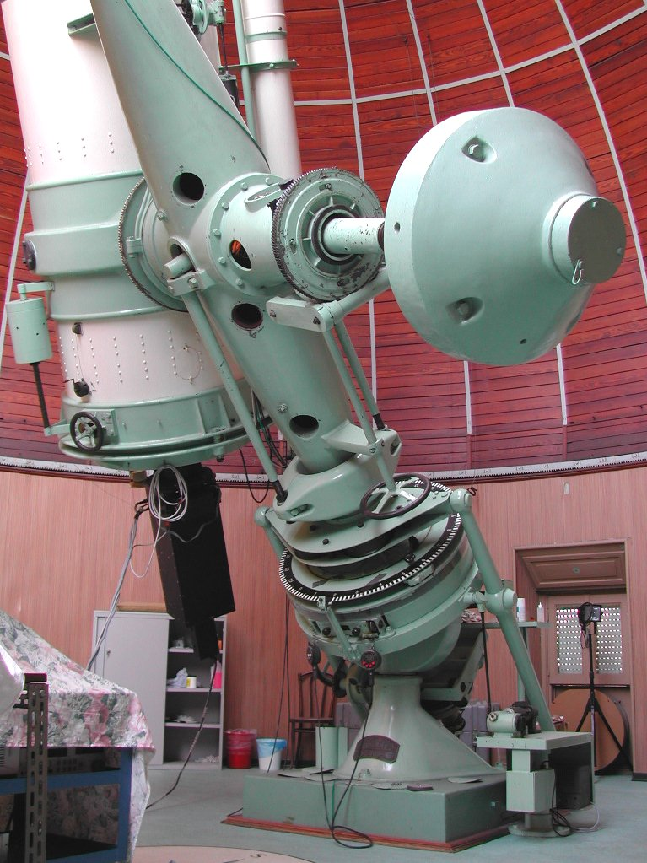

Figure : Zeiss Telescope at the Merate Astronomical Observatory. Mounted on an equatorial mount

(Cav, 2006)

The equatorial mount is an example of one which has limited control of the image rotation. Instead of having an actuator which controls the angle, the geometry of the mount allows the whole telescope to tilt to match the Earth’s rotational axis which causes the image rotation to remain constant, see Figure 4 and Figure 5. This unfortunately creates complicated load paths and often necessitates large counterweight systems.

### Hexapod Mount

The Stewart platform was initially conceived of as a method of simulating flight conditions for pilot training (Stewart, 1965). It is a mechanism based on six independently actuated linear legs which provide six degrees of freedom: x, y, z, pitch, roll, and yaw. Stewart platforms are used in machine tools, flight simulators, and astronomy, see Figure 6 (Koch, et al., 2009).



Figure : Stewart-Gough Platform in use

as a flight training module for Lufthansa (Arnold, 2004)

In 1969, Peter Fellgett proposed the use of the Stewart platform for astronomical purposes using hydraulic actuation. In 1989, a 1.5m prototype of a hexapod telescope was funded in Germany with the intent of proving the concept for use with a 12m telescope. The mechanical system was completed and demonstrated to meet the required specifications but the full telescope was not completed due to complications stemming from the reunification of East and West Germany. (Chini, 2000)

In 2006, observations began at the Array for Microwave Background Anisotropy, see Figure 7 (AMiBA). It is the largest hexapod telescope in operation. The hexapod mount was chosen for this application based on size, weight, accessibility and portability requirements. (Koch, et al., 2009)



Figure : AMiBA in neutral position.

(Koch, et al., 2009)

### Parallel Actuator Mount

The Parallel Actuator Mount is a novel system designed by Garrett Gudgel with guidance from Dr. John Ridgely and Dr. Russell Genet (Gudgel, 2015). Mr. Gudgel approached the issue of transportability, long exposure image rotation, and excess required mass with his telescope mount. In his investigation, he found that current telescope mounting systems could be improved for the use of amateur and small scale research purposes, which did not require full sky coverage nor full 6 degree of freedom capabilities. His goal was to create a system which was less massive and cheaper without sacrificing stiffness or accuracy.



Figure : Solid model showing the design of the Parallel Actuator Mount prototype

(Gudgel, 2015)

His solution to these issues was to design a mount system, based on the AMiBA telescope, which used linear actuators in parallel instead of rotational actuators in series. This allowed him to build image rotation into the system as well as to create shorter loading paths which lower the overall required strength, and thus mass, of each actuator.

The Gudgel mount is a novel modification of the hexapod mount. It is composed of three linear actuators, a stationary three degree-of-freedom ball-in-socket joint, six two degree-of-freedom joints, a baseplate, and a frame which contains and/or represents the telescope.

In this system a large portion of the load is supported by the ball-and-socket joint with the remaining load being shared between the three linear actuators.

# Theory

## Coordinate System Definitions

The Parallel Actuator Mount uses a coordinate system transformation to determine the actuator lengths required to aim the system at the desired point. See Section 3.5 for details on this transformation. This requires the definition of two coordinate systems. One is defined with respect to the unmoving base of the system and the other is defined with respect to the telescope itself.



Figure : XYZ Coordinate system.

The XYZ coordinate system is a global, orthogonal coordinate system. Its origin is at the center of the stationary ball-in-socket joint (see Section 4.1.4) and the axes are defined as shown in Figure 9.



Figure : X'Y'Z' Coordinate System

The X’Y’Z’ coordinate system is local to the telescope itself. It is an orthogonal system with its origin at the center of the stationary ball-in-socket joint. Its axes are defined as shown in Figure 10.

A major feature of these coordinate system definitions is that the origin is at the same point. This allows the transformations to be purely rotational and the translational elements of transformation matrices can be ignored.

## Angles of Interest

As discussed in Section 2.1, this system uses the altitude-azimuth definition of angles of interest. These angles include azimuth, altitude, and image rotation angles which are defined as shown in Figure 11, Figure 12, and Figure 13 respectively.



Figure : Definition of the Positive Azimuth Angle



Figure : Definition of the Positive Altitude Angle



Figure : Definition of the Positive Image Rotation Angle

## Points of Note

There are several points of the system that are used for calculating the position of the system. These include the centers of rotation of the Ground-to-Actuator Rotators (Section 4.1.2), Telescope Rotator Assembly (Section 4.1.4), and Actuator-to-Telescope Rotators (Section 4.1.3). The Ground-to-Actuator centers of rotation are referred to as points Pb. The Actuator-to-Telescope centers of rotation are referred to as points Pr. These are shown in Figure 14. The center of the Telescope Rotator Assembly is referred to as the coordinate systems origin as shown in Figure 9 and Figure 10. The origin and Pb are stationary points that do not change no matter what position the telescope is in. Pr moves based on the location of the telescope. In Figure 14, Pr is shown in the home position Ph.

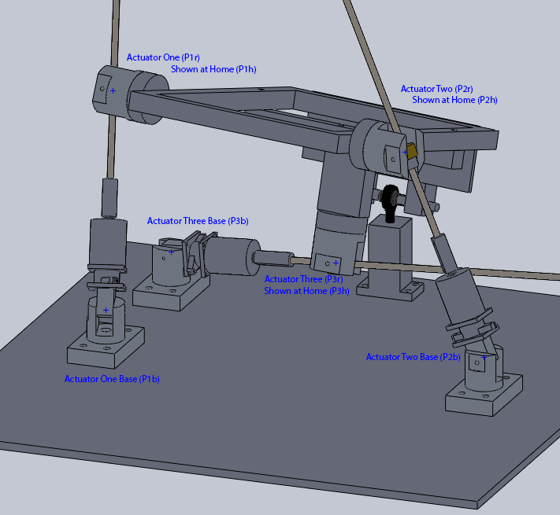

Figure : Points of Note

## Home Position

The Parallel Actuator Mount relies on having an accurately known position to reference. This position is referred to as the home position and is shown in Figure 14. It is created through the use of hard stops on the linear actuators which set a minimum length. When all actuators are at the hard stop the system is in the home position. All position information in the system is incremental, not absolute, so a homing protocol must be done at the beginning of each use in order to tell the system it is in the home position.



Figure : Parallel Actuator Mount in home position

Due to the geometry of the system and the definition of the angles of interest, the home position cannot point at a “clean” position like altitude = 0°, azimuth = 0°, image rotation = 0°. In order to maximize the viewing envelope of the mount, the home position was defined through trial and error.

## Transformations

In order to find the actuator lengths required to match a particular set of altitude, azimuth, and image rotation angles, a known reference position must be defined. This reference position, see Section 3.3, contains complete information of the locations of points of interest: both ends of each actuator, a point on the image axis, and the point of rotation. This position, along with rotation matrices, allows us to find the required lengths.

All desired angular positions are treated as rotations away from the home position. This requires three rotations, one about each of the X, Y, and Z axes.

$$RotX\left(θ\right)=\left[\begin{matrix}1 & 0 & 0 \\ 0 & \cos{θ} & -sin{θ} \\ 0 & \sin{θ} & \cos{θ}\end{matrix}\right]$$

$$RotZ\left(θ\right)=\left[\begin{matrix}\cos{θ} & -\sin{θ} & 0 \\ \sin{θ} & \cos{θ} & 0 \\ 0 & 0 & 1\end{matrix}\right]$$

$$RotY\left(θ\right)=\left[\begin{matrix}\cos{θ} & 0 & \sin{θ} \\ 0 & 1 & 0 \\ -sin{θ} & 0 & \cos{θ}\end{matrix}\right]$$

These transformations align with the angles of interest of the system. A rotation about the X axis is a change of altitude ($θ_{alt}$). A rotation about the Y axis is a change of azimuth ($θ_{az}$). A rotation about the Z axis is a change of image rotation ($θ_{rot}$).

Matrix multiplication is not commutative so care must be given to the order in which the rotations are applied. For this system, the required order is azimuth > altitude > image rotation. This order was determined by examining traditional telescope mounts with series actuators and noting which actuators ‘supported’ others. For example, a change in the azimuth actuator affects both the altitude and image rotation actuators and so must come first.

Note:

* $sTb$ indicates a transformation from the base ‘b’ coordinate system to the telescope ‘s’ coordinate system.
* $\cos{θ}$ and $\sin{θ}$ are abbreviated to $cθ$ and $sθ$ respectively.
* Due to the definition of the angles, the negative of the altitude and azimuth angles are used.

$$sTb=\left[\begin{matrix}c\left(θ_{rot}\right) & -s\left(θ_{rot}\right) & 0 \\ s\left(θ_{rot}\right) & c\left(θ_{rot}\right) & 0 \\ 0 & 0 & 1\end{matrix}\right]\left[\begin{matrix}1 & 0 & 0 \\ 0 & c\left(-θ_{alt}\right) & -s\left(-θ_{alt}\right) \\ 0 & s\left(-θ_{alt}\right) & c\left(-θ_{alt}\right)\end{matrix}\right]\left[\begin{matrix}c\left(-θ_{az}\right) & 0 & s\left(-θ_{az}\right) \\ 0 & 1 & 0 \\ -s\left(-θ_{az}\right) & 0 & c\left(-θ_{az}\right)\end{matrix}\right] \\ sTb=RotZ\left(θ_{rot}\right)*RotX\left(-θ_{alt}\right)*RotY(-θ_{az})$$

However, this transformation only works if the home position is aligned with θalt=0°, θaz=0°, and θrot=0°. A set of corrective rotations must also be included. These three correction angles ($ϕ_{alt}, ϕ_{az}, ϕ_{rot}$) are simply an additional set of rotation matrices that must be applied.

$$sTb=\left[\begin{matrix}c\left(θ_{rot}\right) & -s\left(θ_{rot}\right) & 0 \\ s\left(θ_{rot}\right) & c\left(θ_{rot}\right) & 0 \\ 0 & 0 & 1\end{matrix}\right]\left[\begin{matrix}c\left(ϕ_{rot}\right) & -s\left(ϕ_{rot}\right) & 0 \\ s\left(ϕ_{rot}\right) & c\left(ϕ_{rot}\right) & 0 \\ 0 & 0 & 1\end{matrix}\right]\left[\begin{matrix}1 & 0 & 0 \\ 0 & c\left(-θ_{alt}\right) & -s\left(-θ_{alt}\right) \\ 0 & s\left(-θ_{alt}\right) & c\left(-θ_{alt}\right)\end{matrix}\right]$$

$$\left[\begin{matrix}1 & 0 & 0 \\ 0 & c\left(ϕ_{alt}\right) & -s\left(ϕ_{alt}\right) \\ 0 & s\left(ϕ_{alt}\right) & c\left(ϕ_{alt}\right)\end{matrix}\right]\left[\begin{matrix}c(-θ_{az}) & 0 & s(-θ_{az}) \\ 0 & 1 & 0 \\ -s(-θ_{az}) & 0 & c(-θ_{az})\end{matrix}\right]\left[\begin{matrix}c(ϕ_{az}) & 0 & s(ϕ_{az}) \\ 0 & 1 & 0 \\ -s(ϕ_{az}) & 0 & c(ϕ_{az})\end{matrix}\right]$$

Note that when two rotations about the same axis are applied they can be done in either order.

$$RotX\left(θ_{1}\right)*RotX\left(θ_{2}\right)=\left[\begin{matrix}1 & 0 & 0 \\ 0 & c{θ_{1}} & -s{θ_{1}} \\ 0 & {s{θ}}_{1} & c{θ_{1}}\end{matrix}\right]\left[\begin{matrix}1 & 0 & 0 \\ 0 & c{θ_{2}} & -s{θ_{2}} \\ 0 & {s{θ}}_{2} & c{θ_{2}}\end{matrix}\right] \\ =\left[\begin{matrix}1 & 0 & 0 \\ 0 & c{θ_{1}}c{θ_{2}}-s{θ_{1}}s{θ_{2}} & -(c{θ_{1}}s{θ_{2}}+s{θ_{1}}c{θ_{2}}) \\ 0 & c{θ_{2}}s{θ_{1}}+s{θ_{2}}c{θ_{1}} & c{θ_{2}}c{θ_{1}}-s{θ_{2}}s{θ_{1}}\end{matrix}\right] \\ =\left[\begin{matrix}1 & 0 & 0 \\ 0 & c{{(θ}_{1}+θ_{2})} & -s{{(θ}_{1}+}{θ_{2})} \\ 0 & s{{(θ}_{1}+}{θ_{2})} & c{{(θ}_{1}+θ_{2})}\end{matrix}\right] \\ =RotX(θ_{1}+θ_{2}) \\ =RotX(θ_{2}+θ_{1})$$

This allows for a simplified combined transformation:

$$sTb{(θ}_{alt}, θ_{az},θ_{rot})=RotZ\left(θ_{rot}+ϕ_{rot}\right)*RotX\left(-θ_{alt}+ϕ_{alt}\right)*RotY(-θ_{az}+ϕ_{az})$$

The correction angles are constants based on the design of the system and thus do not add to inputs required for the transformation during the run of the telescope. This combined transformation allows an expression to be formed which takes as input the three angles of interest and, along with knowledge of the home position, outputs the end positions of the linear actuators required to achieve those angles.

Let P1h, P2h, P3h represent the coordinates of the actuator ends in the base coordinate system while in the home position and P1r, P2r, P3r represent the coordinates of the actuator ends after a rotation has occurred. This results in the fundamental equation for this system:

$$\left[\begin{matrix}P_{r}x \\ P_{r}y \\ P_{r}z\end{matrix}\right]=sTb(θ_{alt}, θ_{az},θ_{rot})*\left[\begin{matrix}P_{h}x \\ P_{h}y \\ P_{h}z\end{matrix}\right]$$

Once the rotated end positions of the linear actuators have been found, the distance formula is applied between these new end positions and the base position of the actuator in order to calculate the required length for each actuator.

$$L= \sqrt{{\left(P_{r}x-P_{b}x\right)}^{2}+{\left(P_{r}y-P_{b}y\right)}^{2}+{\left(P_{r}z-P_{b}z\right)}^{2}}$$

## Angular Velocities

Two methods were attempted for calculating the required linear velocities to produce the desired angular velocities. The first, taking the time derivative of a transformation matrix, would be a more elegant solution but requires more information than is available in the system. The second, forward calculating what length would be required after a specified time step, requires certain assumptions to be made but is able to be implemented in the system.

### Time Derivative of a Transformation Matrix

As discussed in Section 3.1 , transformation matrices are used to create a relationship between actuator lengths and system angular position. The time derivative of those transformation matrices should allow for the creation of a relationship between the actuator linear velocities and the system angular velocities. However, because these velocities must continually change over the course of the movement, knowledge of the current length and velocity at each time step are required as input.

### Forward Calculation of Desired Position

Angular velocities are calculated by discretizing the movement over small time steps. The first step is to determine what length each actuator should have at some specific moment in the future. Basic kinematic equations with constant angular acceleration lead to:

$$θ_{new}= θ_{current}+ω*t_{step}$$

Utilizing the transformations developed in section 3.5, in conjunction with these new angular positions, results in the required lengths of each actuator.

$$L_{ new}=f(θ_{altitude new}, θ_{azimuth new},{ θ}_{rotation new})$$

The definition of linear velocity as the rate of change of position is then used to calculate the required angular velocity based on the physical system.

$$V=\frac{L_{ new }-L_{ current}}{t_{step}} \\ stepsPerSec=V\left[\frac{inch}{second}\right]* threadPitch \left[\frac{rotations}{inch}\right]*stepperAccurancy\left[\frac{steps}{rotation}\right]$$

Once the system has run for $t_{step}$ time, the process starts over and a new future position is calculated.

This method assumes that the magnitude of the acceleration is sufficient such that the velocity over the time step can be treated as constant. If a system does not accelerate fast enough, this method will result in significant positional error.

## Pointing a telescope

# Design

## State of Previous System

The system as received from Mr. Gudgel was a solid proof of concept with a few design choices that were not optimal for this continuation of the project.

### Linear Actuators

The linear actuators for the system (Figure 16) received were made up of several parts. Linear movement was generated with an Acme threaded rod rigidly mounted to the output shaft of a DC motor with gearbox. A nut moved along the threaded rod to create the linear motion.



Figure : Original Linear Actuator

### Ground-to-Actuator Rotator Assembly

The Ground-to-Actuator Base Rotator assembly (Figure 17) was the connection between the base plate and the motor. It constrained the motion such that the motor could drive the threaded rod without the motor body spinning. A possible singularity position existed if the motor output shaft was in a vertical position. The geometry of the system prevented this position from being reached.



Figure : Ground to Actuator Rotator Assembly

(Gudgel, 2015)

### Actuator-to-Telescope Rotator Assembly

The Actuator-to-Telescope Rotator assembly (Figure 18) connected the nut which moved on the linear actuator to the rigid body of the telescope. This assembly prevented the nut from spinning freely and thus caused it to travel along the threaded rod as the rod spinned.



Figure : Actuator to Telescope Rotator Assembly

(Gudgel, 2015)

### Telescope Rotator Assembly

The Telescope Rotator assembly (Figure 19) was the stationary joint about which the telescope rotated. This joint was the origin for all transformation calculations. It was built from a ball joint rod end, a shaft, and several simple machined parts.



Figure : Telescope Rotator Assembly

(Gudgel, 2015)

### Electronics and Software

The electronics provided are built around a Mbed LPC1768 Prototype board which is programmed in mbed C++. It communicates with a partner program on a computer and controls a custom board, Figure 20, with three DC motor drivers and three encoder counter circuits.  
There is a secondary piece of electronics which controls the focusing mirror stepper motor, see Figure 21.



Figure : Mbed LPC1768 Prototype board with custom motor driver board installed

(Gudgel, 2015)



Figure : Secondary electronics for control of telescope's focusing mirror

(Gudgel, 2015)

Along with the software onboard the Mbed, a Python program with user interface was written. This program support telescope calibration, positioning, and emergency shutoff.

## Design Guidelines

The Parallel Actuator Mount has three general parts that need to be taken into account: rotators, linear actuators, and system geometry.

### Rotators

### Linear Actuators

The linear actuators are made up of a motor, some sort of method of converting rotational motion to linear motion, and something to couple the motor to the converting device.

#### Motors

There are two general options for the motor of this system: DC motor with gearbox or stepper motor. Other options exist, such as servo motors, but they are generally much more expensive or otherwise do not fit the requirements of the parallel actuator mount.

The original parallel actuator mount utilized DC motors with gearboxes. These were changed to stepper motors to lower cost and simplify the control scheme.

DC motors excel at high velocity, low torque motion. They have no inherent knowledge of their own position and require an encoder for position control. In order to make a DC motor suitable for this system, a gear box is required. Gearboxes add expense and inaccuracy to the system through the introduction of backlash.



Figure : Stepper Motor Assembly

Stepper motors are the least expensive method of implementing precise angular motion. They are used in many industries including having a strong presence in the astronomy field (Anaheim Automation). Stepper motors, in conjunction with high quality drivers, are very simple to control for both position and velocity. Stepper motors do not require an encoder which creates a simpler, cheaper control system. Stepper motors excel at outputting high torque at low speeds without requiring the use of gearboxes.

The largest issue with the change to stepper motors is that it shifts closed loop control from the motor/encoder to a telescope camera and plate solver. As the camera and plate solver are beyond the scope of this project, the system must be run with an open loop control scheme and it must be assumed that a commanded position change occurs instead of being able to track the change. This is a decent assumption if the stepper motors are rated appropriately for the system requirements.

Selecting a stepper motor requires knowledge of the torque requirements, accuracy requirements, and velocity requirements of the system.

For this system, the torque requirements can be calculated based on the torque required to raise a load using a screw :

$$T_{r}=\frac{Fd_{m}}{2}\left(\frac{l+π*fd_{m}}{πd_{m}-fl}\right)$$

Where:

$$T_{r}=torque required to raise the load \\ F=axial load \\ d_{m}=mean diameter of screw \\ f=coefficient of friction between screw and nut \\ l=lead of screw, advancement per revolution$$

Unfortunately, accurately measuring the axial load on the actuator is very difficult. An estimate was established through use of a pull scale. It was attached to the Actuator-to-Telescope rotator and pulled in the direction of the acme rod until the nut could be moved freely. The highest reading found was approximately 25 pounds which would indicate a torque requirement of 0.10 Nm. However, it seems that a much higher torque was actually required.

#### Lead Screws

Acme screws vs Ball screws

#### Bearings and Coupler

Bearings to prevent motor from seeing axial load and moments

If proper bearings, flexible shaft coupler is acceptable.

### Geometry

Singularity points

Centers of gravity

### Distribute into above sections

There were several issues with the build of the physical system. The two primary issues were non-concentricity of the Motor-Threaded Rod couplers, which led to significant wobble in the rods, and too loose of tolerances in the Ground-to-Actuator Rotator and Actuator-to-Telescope Rotator assemblies which added significant backlash to the system.

One of the couplers which transmit motion from the motor to the threaded rod had a manufacturing defect where the input and output sides of the couple were non-concentric. This caused significant wobble during motion. Remanufacturing this coupler resulted in a visible increase in the smoothness of the telescope motion.

All of the rotators have aluminum against aluminum interfaces over a relatively large surface area and steel shafts which move directly against aluminum. Both of these interfaces have large frictional coefficients (Friction and Friction Coefficients). These interfaces were all greased to lower the frictional coefficient and help prevent binding.

Several of the rotators also either had too loose of manufacturing tolerances or had worn enough that there was excess movements in the joints. Although it would have been better to re-machine these components, they require a major redesign which is outside the scope of this thesis (See Section 6.1). Adding shims helped alleviate this issue.

### Frame instead of telescope

The telescope and rails used in the previous system are very heavy. It was decided to replace the telescope with an aluminum frame for the purpose of this project in order to ensure the accuracy of the assumption described in section **Error! Reference source not found.**.

## Electrical Modifications

The electronics were replaced by off the shelf products as much as possible. This was possible because STMicroelectronics has created a prototyping environment which allows access to a wide range of STM32 microcontrollers and can easily incorporate a wide variety of expansion boards. These boards can also be programmed in many different languages.

Figure : Fully Assembled Electronics Stack

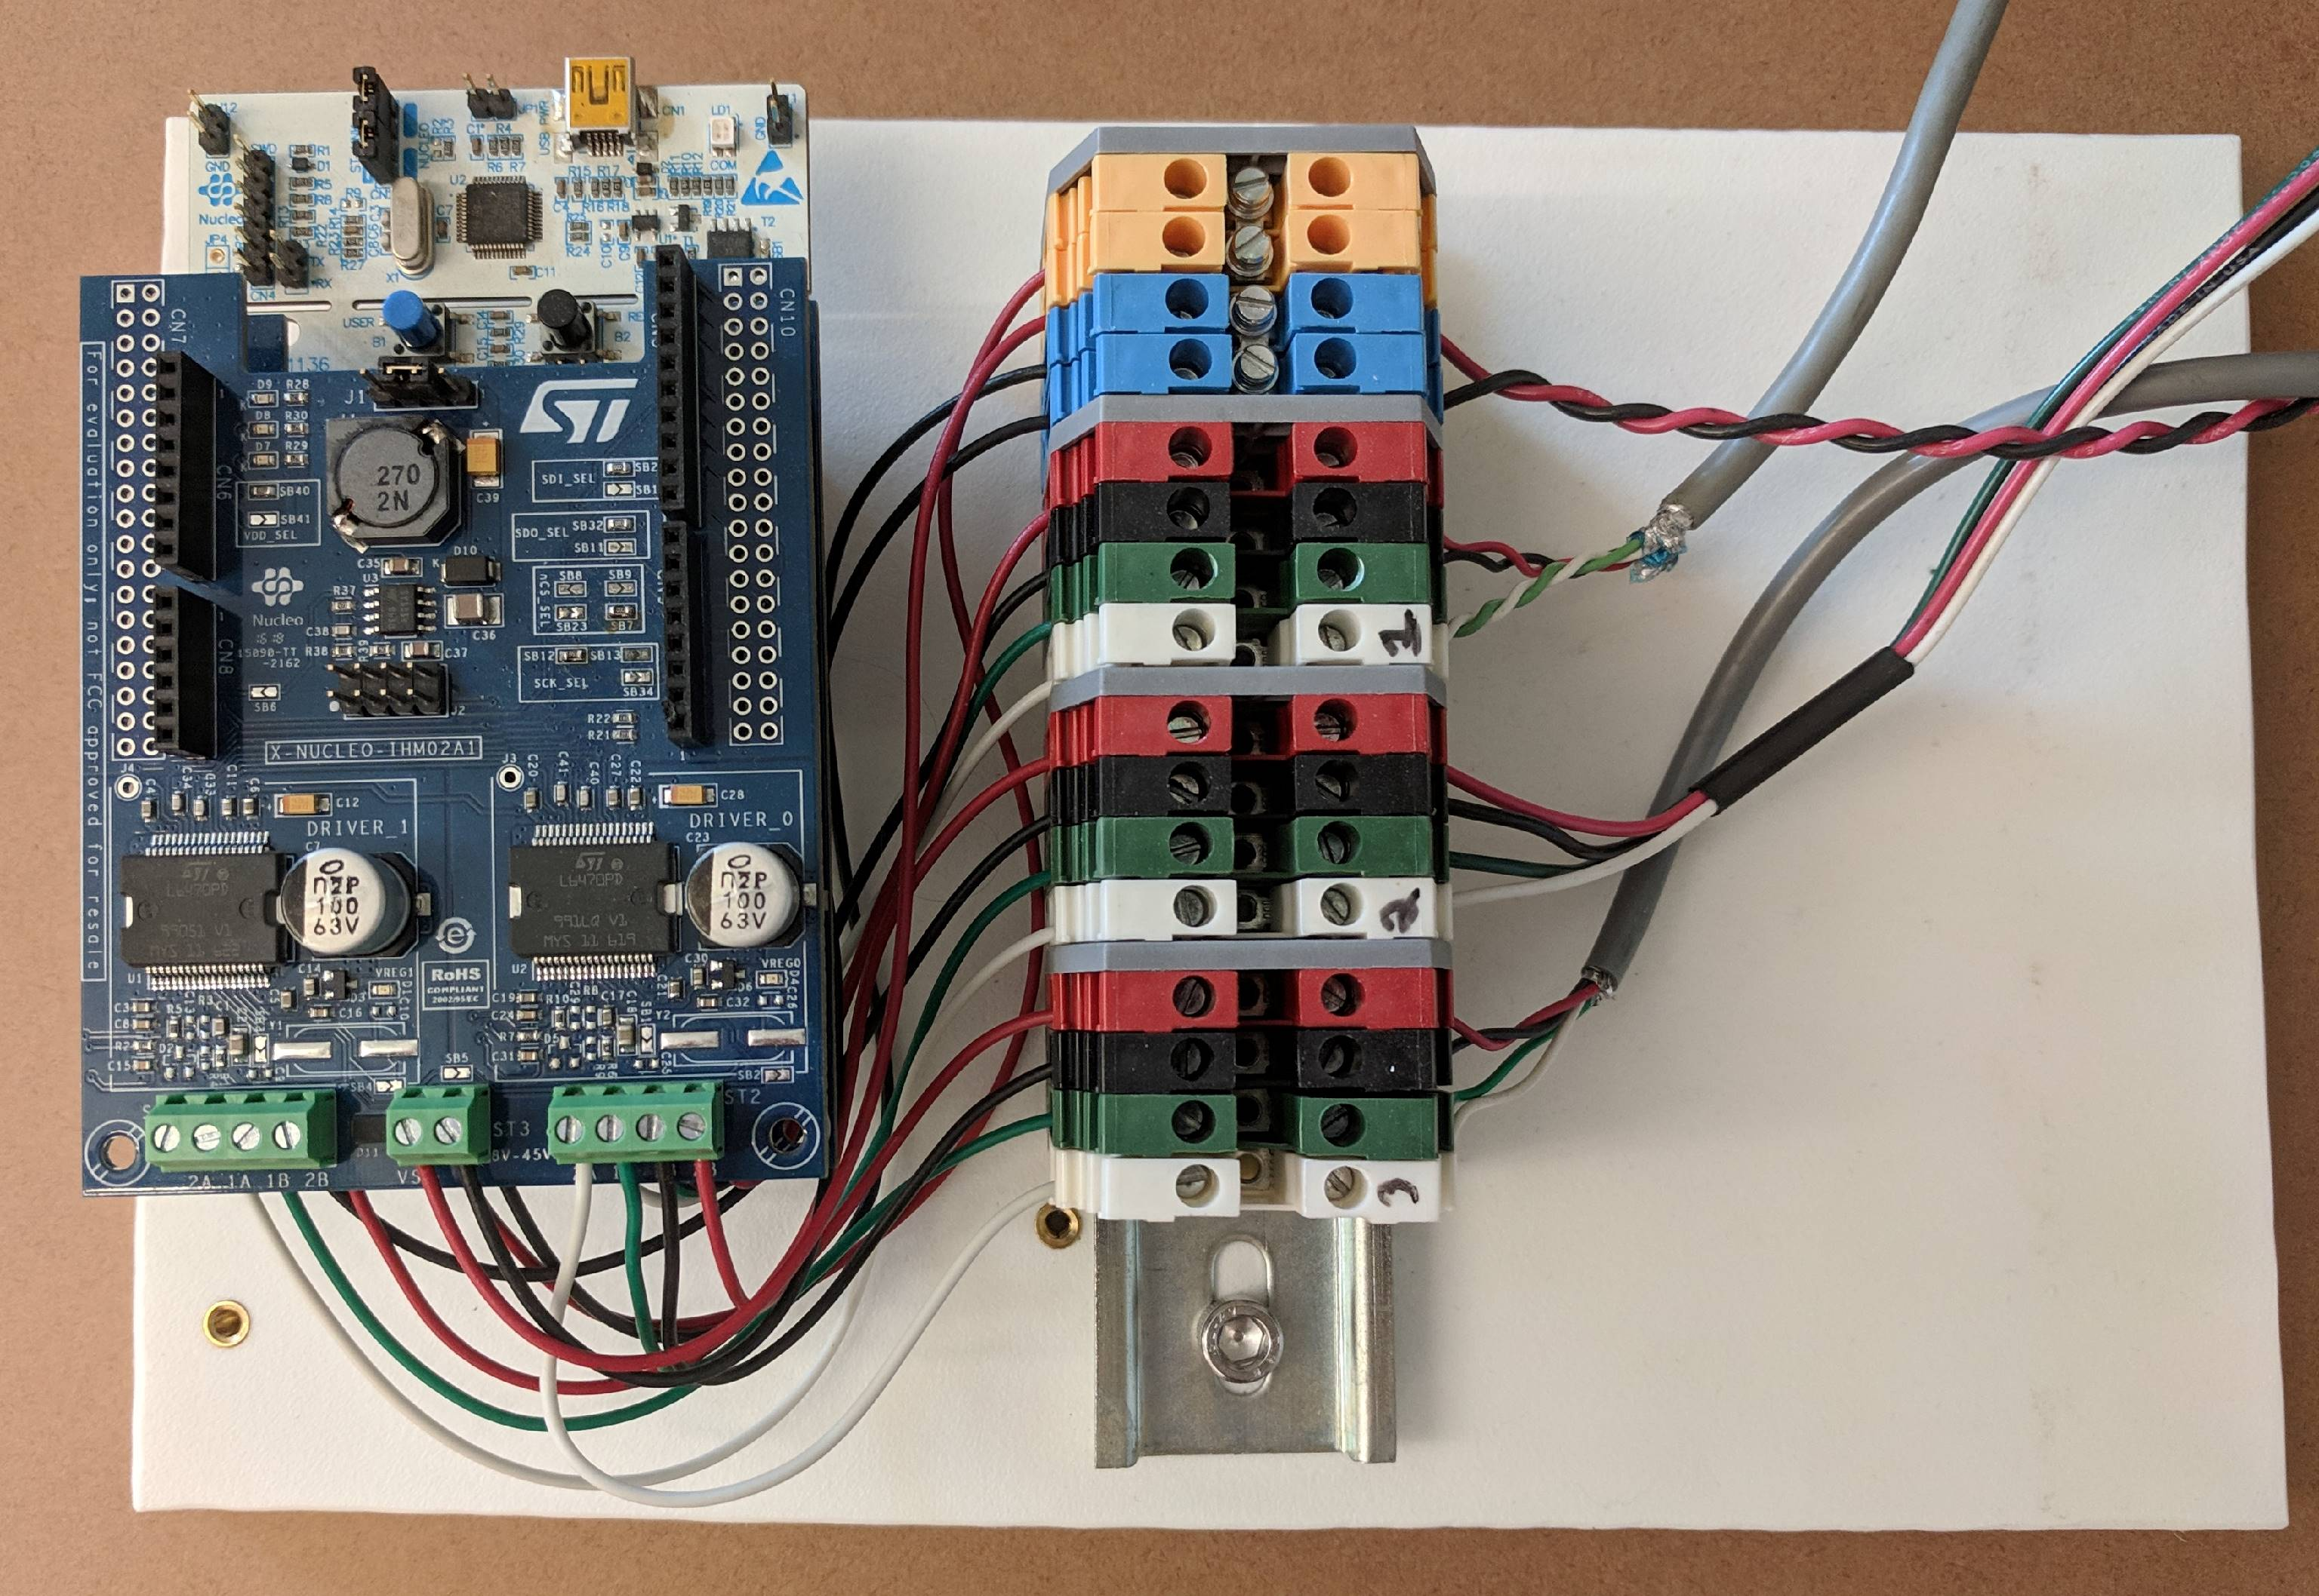

### STM32 Nucleo Development Board with STM32L476RG MCU

The STM32L476RG is an 80MHz, 32-bit ultra-low-power microcontroller with a built in floating point unit. It was selected over other models of the STM32 family due to its 1 Mbyte of Flash memory (STMicroelectronics).

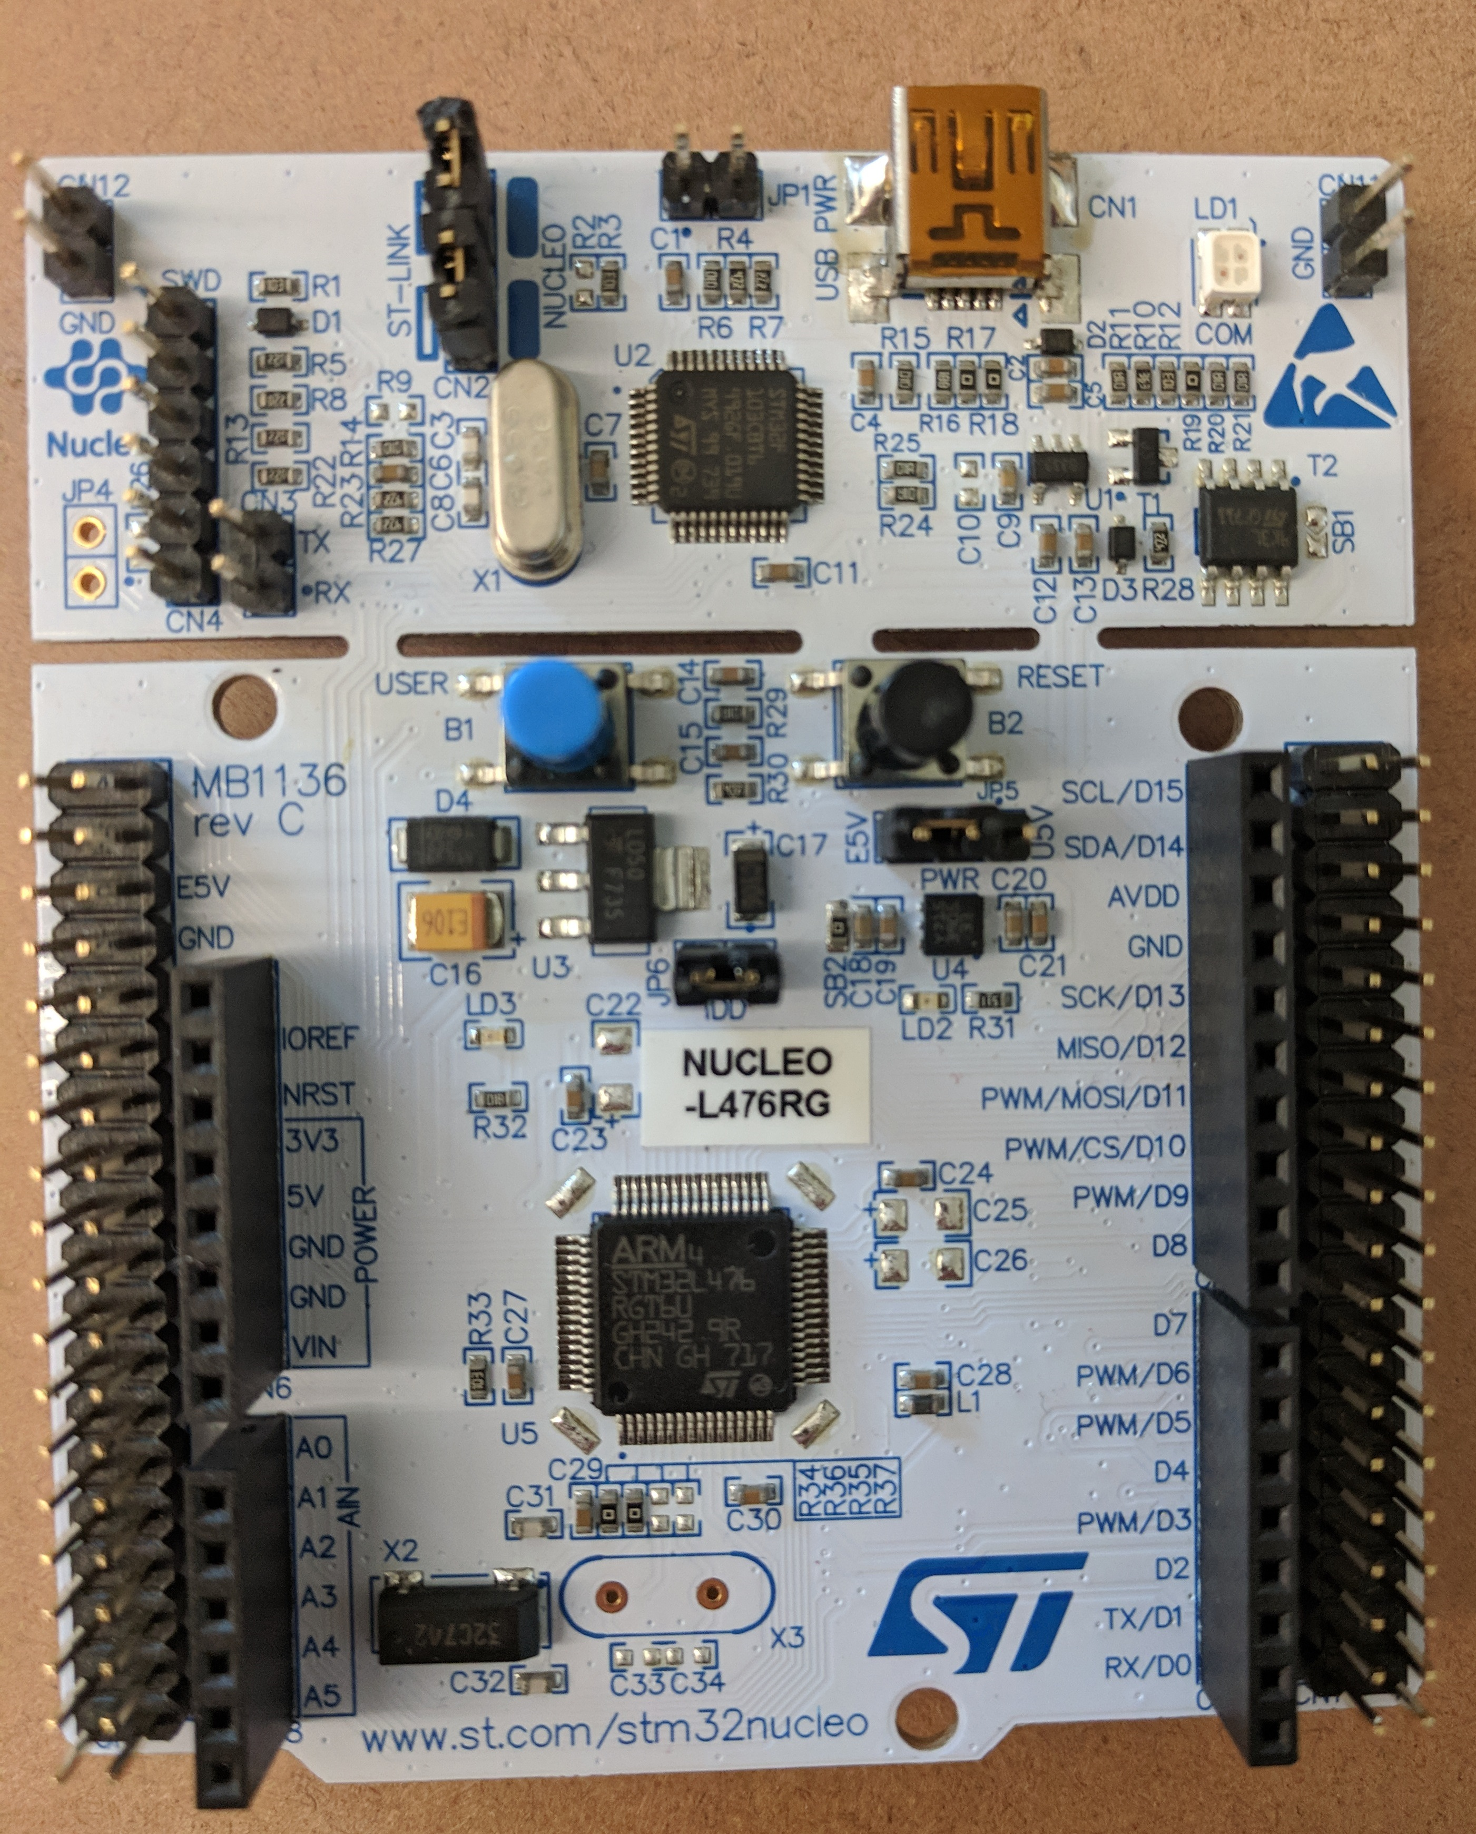

Figure : ST Nucleo L476RG

### ST L6470 Stepper Motor Drivers

The L6470 stepper motor driver from ST is a fully integrated bipolar stepper motor driver with microstepping (STMicroelectronics). This driver is communicated with over i2c and is “smart”. An onboard microprocessor handles the stepper motor feedback and control. It allows for simple commands to be sent such as ‘Run’, ‘Move’, and ‘GoHome'. This greatly simplifies the control scheme for the project.

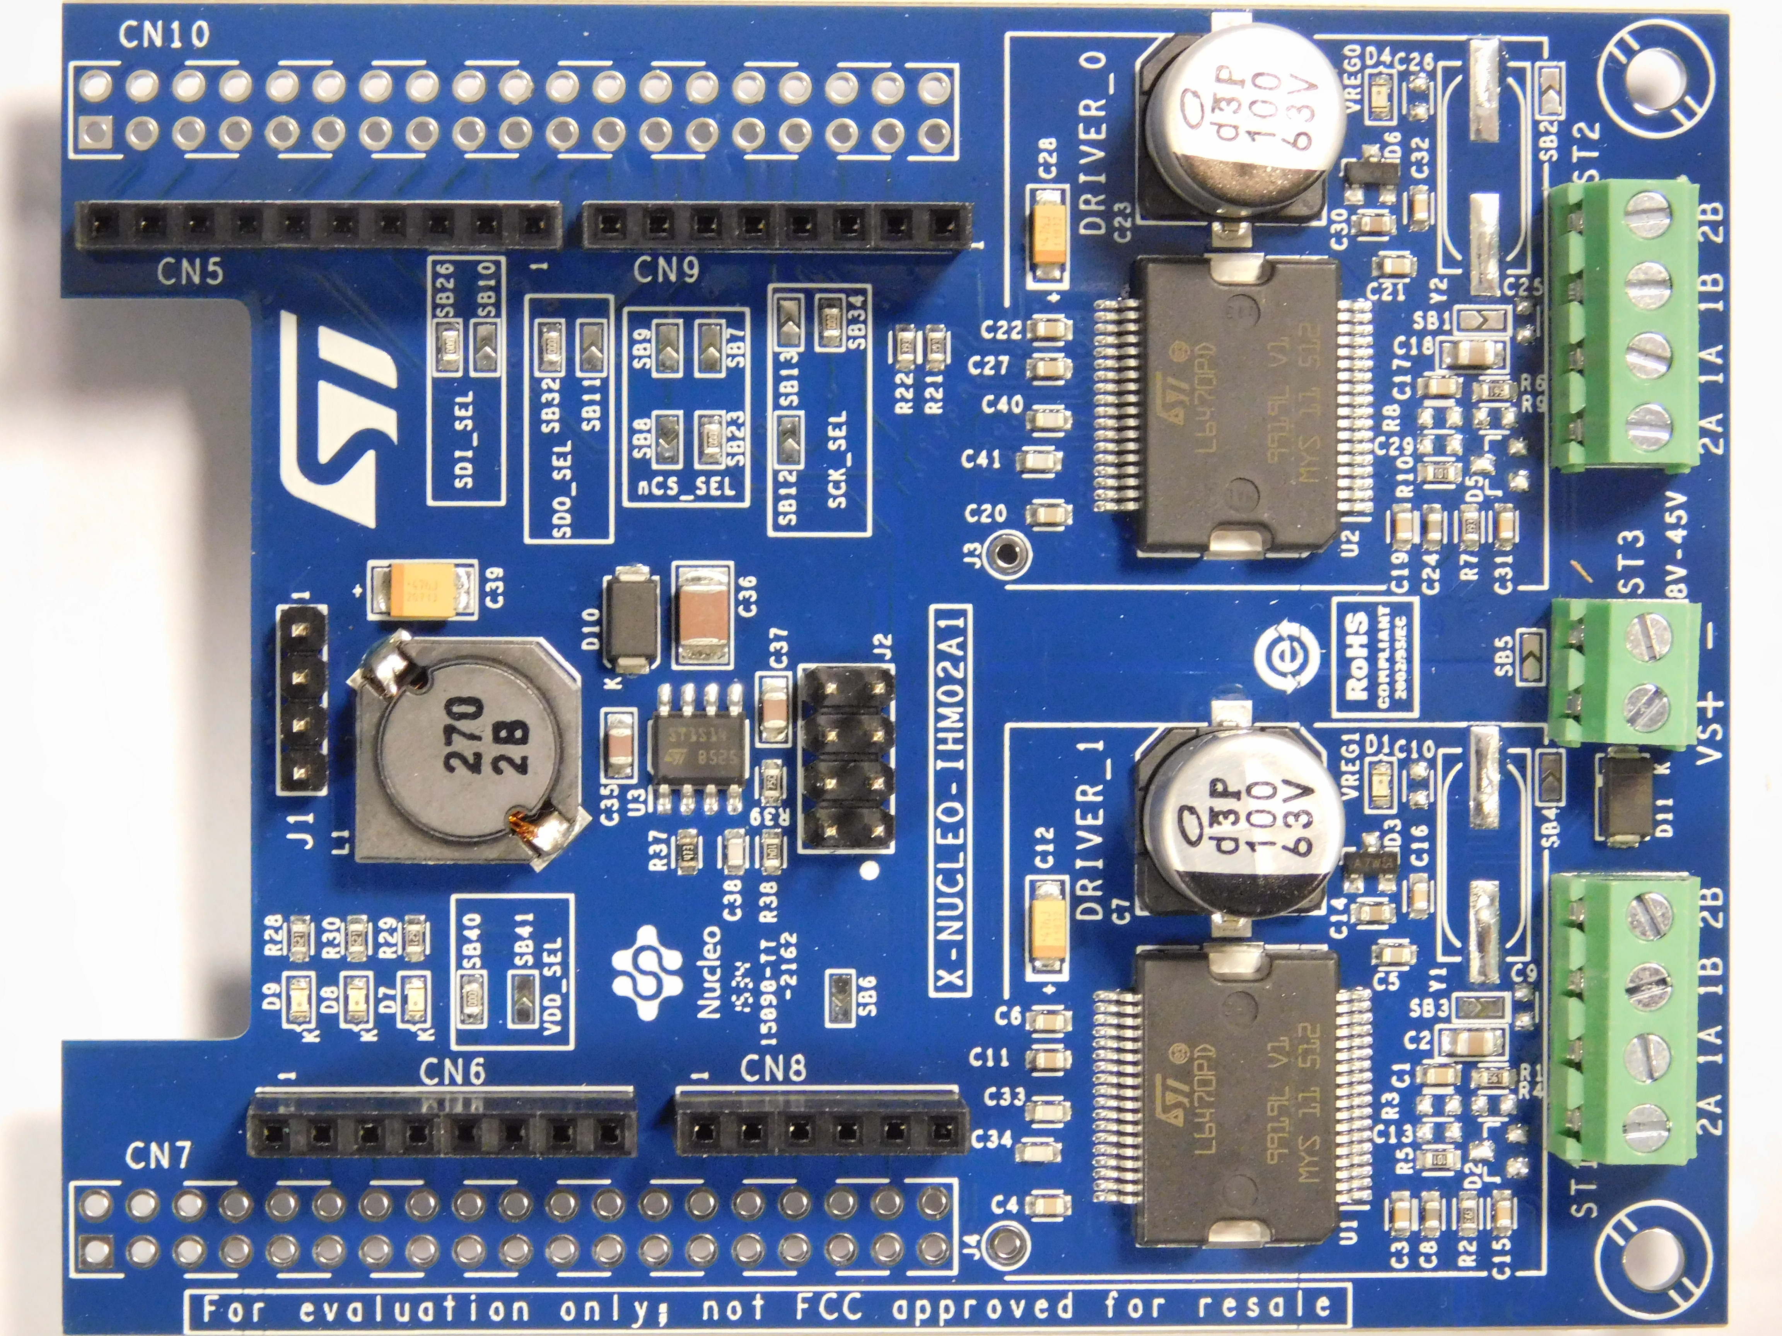

Figure : ST L6470 Stepper Motor Driver

### Shoe of Brian

The Shoe of Brian is the only custom pcb required for this system. It is a simple board which allows for the STM32L476RG to run Micropython instead of its default Mbed. It was designed by Dr. John Ridgely for use in his mechatronics classes.

­­­

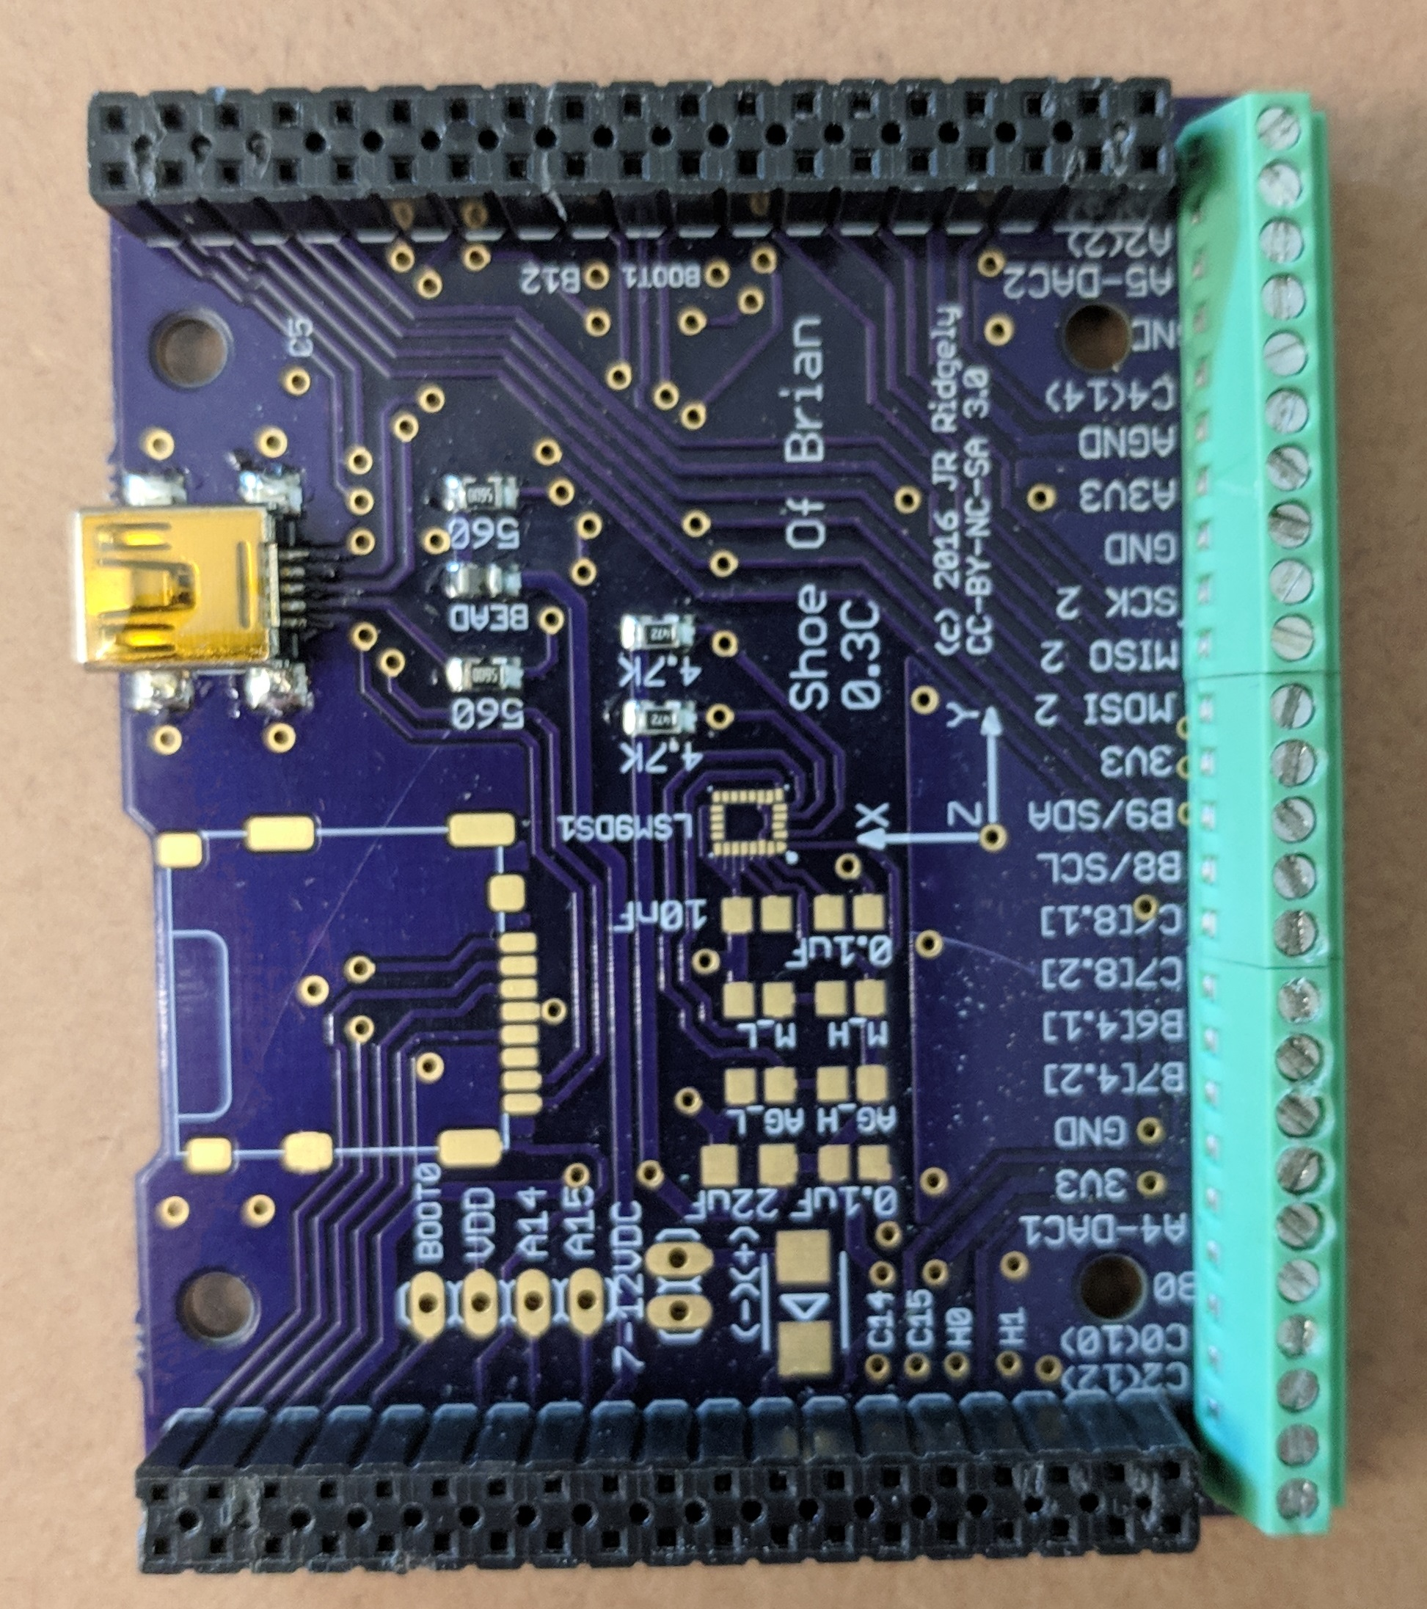

Figure : Shoe of Brian Custom PCB

## Software Modifications

It was decided to write this project in Micropython because it allowed for easier development, the code could be easy for other users to modify, and it gives access to utilities like AstroPy.

### Program architecture

The control program is built from a series of objects which build upon each other. These objects include the L6470 driver, the actuator driver, and the telescope driver.

The lowest level object is found in l6470nucleo.py. The Dual6470 class contains methods for communicating directly with the stepper motor drivers. The L6470 is a ‘smart’ stepper motor driver so the software driver does not have to implement a control system and instead just has to send commands to the chip.

The Actuator class is found in ActuatorDriver.py. Each instance of this object represents one of the linear actuators in the system. It requires an associated L6470 object and information about how the system changes the rotational motion of the stepper motor to linear motion.

The Telescope class in TelescopeDriver.py represents one full Parallel Actuator Mount. This class requires three Actuator objects. This is where the geometry of the system is defined and where the transformations in Section 3.1 are implemented. It is also where the velocity calculations from Section 3.6 are implemented. The basic set of commands for interfacing with the telescope remain at this level.

The final layer of the program is main.py which sets up all the above objects and allows for definition of custom commands.

### Program usage

A minimal set of commands have been defined for user interaction with the telescope. Basic commands for control of the telescope are at the Telescope object level. These include commands such as *goVelocity,* which commands the telescope to move at specified angular velocities, *goToAngles*, which calculates the correct lengths of the linear actuators for the input angles of interest then commands the calculated motion, and *resetPosition*, which defines the current position the home position.

Customizable commands are contained in main.py. Several commands were setup for testing including things such as:

* *Estop* – stops each motor as quickly as possible. Directly interacts with the L6470 drivers
* *Go* – moves each stepper motor at a specified speed.
* *testRepeatability* – runs through a series of points multiple times for the Long Run Repeatability test found in Section 5.2.3.3
* *testGrid* – runs through all the points in a grid, pausing in between each point

# Testing and Verification

## Testing Set Up

All tests have been performed using laser diodes mounted to the front of the telescope stand in frame. Three lasers were required to perform all the tests. The primary laser was used for repeatability tests and relative angular motion tests. This laser was mounted on an axis parallel to the telescope optical axis and goes through the center of the pivot point. The alignment of this laser was not critical for repeatability tests but was vital for relative motions tests. Deviation from the described positioning can have a major impact on comparative measurements.



Figure : Laser diodes mounted for testing

The second and third lasers were used for measuring relative image rotation angle. They were also mounted parallel to the telescope optical axis but they did not need to go through the center of the pivot point. These two lasers were on the same level such that if the telescope were pointed at a wall with all angles at 0, the two marks would be horizontal.

The apparatus was oriented relative to a vertical surface (wall) with the X-Y plane parallel to the wall and the X-Z plane perpendicular to the wall. The origin of the apparatus was as far as possible from the wall such that the optical axis laser remained on the wall at the extremes of the desired testing area.

## Test Descriptions

### Relative Positioning

The current system does not have an absolute reference for its positioning so all position testing must be done as relative testing. This is sufficient for the purpose of this thesis because a future refinement would be to incorporate feedback via a plate solver.

#### Rotation

The relative rotation test is designed to test the relative accuracy of commanded image rotations. This test utilizes two laser diodes mounted on the front of the telescope. The telescope is commanded to a position with zero image rotation angle, then the two lasers are marked on the wall this will be the reference angle. Without moving the telescope base, it is commanded to another position with the same altitude and azimuth but different image rotation. The lasers are again marked on the wall. These sets of points are connected to create two lines which should be at the commanded image rotation angles relative to the horizontal. A photograph of these lines is then taken to be analyzed.



Figure : Relative Rotation Test

The angle of the reference line and the angle of the other lines position are measured via Matlab (**Error! Reference source not found.**). As shown in Table 1, the measured angle of the reference line can be subtracted from the angle of the other lines in order to calculate a corrected, relative, angle.

Table : Relative Rotation Test Results

|  |  |  |  |  |
| --- | --- | --- | --- | --- |
|  | Commanded Angle [rad] | Measured Angle [rad] | Corrected Angle [rad] | % Error |
| Zero Line | 0 | 0.1655 | 0 |  |
| Positive Line | 0.1 | 0.2651 | 0.0996 | -0.40% |
| Negative Line | -0.1 | 0.0698 | -0.0957 | -4.30% |

#### Altitude

The Altitude Relative Position Test used a series of commanded angles to measure how accurate the system is at changing altitude. The desired angles were commanded and marked on the board. The distance of these positions above the reference commanded point was measured as well as the orthogonal distance from the board to the system origin. As the system is not physically able of pointing at altitude = 0°, the reference commanded point was chosen as 17°.

 

Figure : Altitude Relative Position Test

, 0° Azimuth and 10° Azimuth. Numbers below angles are millimeters above 17°

The distance to the board along with the commanded angles were used to calculate the theoretical height the system would point above altitude = 0°.

$${heightAboveZero}_{theoretical}= distanceToBoard_{orthogonal}*\frac{\tan{θ_{alt}}}{\cos{θ_{az}}}$$

For each point, the distance measured above the reference point was subtracted from the theoretical height to find where the reference point would be assuming the current point is in the correct spot.

$$heightZeroToRef=heightAboveZero_{theoretical}-heightAboveRef_{measured}$$

When this height is close to the theoretical height of the reference point above zero, the system is performing well.

Table : Altitude Relative Position Test. Azimuth = 0°, DistanceToBoard = 1295mm

|  |  |  |  |  |
| --- | --- | --- | --- | --- |
| Command Angle [deg] | Theoretical Height Above Zero [mm] | Measured Height Above Ref [mm] | Height from Zero to Ref [mm] | % Error |
| 17 | 395.92 | 0 | 395.92 | 0.00% |
| 20 | 471.34 | 76 | 395.34 | -0.15% |
| 22.5 | 536.41 | 140 | 396.41 | 0.12% |
| 25 | 603.87 | 205 | 398.87 | 0.74% |
| 27.5 | 674.13 | 276 | 398.13 | 0.56% |
| 30 | 747.67 | 350 | 397.67 | 0.44% |
| 32.5 | 825.01 | 423 | 402.01 | 1.54% |
| 35 | 906.77 | 504 | 402.77 | 1.73% |
| 37.5 | 993.69 | 586 | 407.69 | 2.97% |
| 40 | 1086.63 | 676 | 410.63 | 3.72% |
| 42 | 1166.02 | 749 | 417.02 | 5.33% |
| 45 | 1295.00 | 873 | 422.00 | 6.59% |

Table : Altitude Relative Position Test. Azimuth =10°, DistanceToBoard = 1295mm

|  |  |  |  |  |
| --- | --- | --- | --- | --- |
| Command Angle [deg] | Theoretical Height Above Zero [mm] | Measured Height Above Ref [mm] | Height from Zero to Ref [mm] | % Error |
| 17 | 402.03 | 0 | 402.03 | 0.00% |
| 20 | 478.61 | 77 | 401.61 | -0.10% |
| 22.5 | 544.68 | 141 | 403.68 | 0.41% |
| 25 | 613.18 | 209 | 404.18 | 0.54% |
| 27.5 | 684.53 | 278 | 406.53 | 1.12% |
| 30 | 759.20 | 351 | 408.20 | 1.54% |
| 32.5 | 837.73 | 427 | 410.73 | 2.17% |
| 35 | 920.76 | 510 | 410.76 | 2.17% |
| 37.5 | 1009.02 | 593 | 416.02 | 3.48% |
| 40 | 1103.40 | 684 | 419.40 | 4.32% |
| 42 | 1184.01 | 760 | 424.01 | 5.47% |

Figure : Altitude Relative Position Test. Azimuth = 0°

, DistanceToBoard = 1295mm. Error bars showing deviation of measured from expected

Figure : Altitude Relative Position Test. Azimuth = 0°

, DistanceToBoard = 1295mm. Error bars showing deviation of measured from expected

As seen in Figure 30 and Figure 31, the deviation from the expected distance increases as the altitude increases for both tests but remains small overall.

### Velocity

Velocity testing was accomplished by commanding the apparatus to two points and marking them on the wall. When the apparatus was aimed at one of the points, it was commanded along the vector that would intersect with the second point. The motion was filmed then analyzed to find the velocity.

VLC was used to find the time motion began and the time when the laser passed the second mark. This allowed for the calculation of angular velocity when combined with the angular distance between the points.

The test was run twice for a purely altitude motion and twice for a purely azimuth motion.

### Repeatability

Repeatability was tested by moving between a series of points multiple times and seeing how much deviation there was between the first time and subsequent moves. It was done using a laser diode attached along the axis of the telescope. Setting the mount a known distance from a whiteboard, the mount was commanded to move to various altitude and azimuth positions. Image rotation was held constant at theta3 = 0. After each move, the location of the laser on the whiteboard was marked. Three sets of motions were examined:

#### Altitude Repeatability

The Altitude Repeatability test moved back and forth between two azimuth positions holding altitude and image rotation constant. The test started the system aimed at the 0.3 rad point. As shown in Figure 32, the system returned precisely to the previous position each cycle but the point which it returned to for 0.3 rad was not the same point as it had started at.



Figure : Altitude Repeatability Test

. Mount traveled between points five times. Arrows indicate the laser was on top of a previous point.

#### Complex Repeatability

The Complex Repeatability test first established reference points by commanding the telescope to six positions and marking those positions on the board in blue. After this, three tests were run which moved between the points in different ways:

The first test, labeled 2A, moved from point 6 to each other point and returned to point 6 in between.

The second test, labeled 2B, moved from point 2 to each other point and returned to point 2 in between.

The third test, labeled 2C, moved through the points 6>5>4>3>2>1>6.



Figure : Complex Repeatability Test 2A



Figure : Complex Repeatability Test 2B



Figure : Complex Repeatability Test 2C

#### Long Run Repeatability

The Long Run Repeatability test cycled through seven points ten times and marked the laser at the first and last cycle.



Figure : Long Run Repeatability Test Setup





Figure : Long Run Repeatability Test Close View of Results

### “Wobble”

I’m not sure what to call this section. Basically measuring how much variance in position the system can have when commanded to a specified angle.

# Conclusion

## Rotators

As discussed in section 4.2.3, the rotators currently rely on aluminum/aluminum and aluminum/steel interfaces. A major improvement to this system would be to redesign the rotator assemblies with either bearings or bushings. This would allow much tighter tolerances and help to mitigate (THE SLOP IN THE SYSTEM WITH HOW THE WHOLE THING CAN BE MOVED TO DIFFERENT POSITIONS WITHOUT CHANGING LENGTHS)

## Linear Actuators

## Control Feedback

Feedback from plate solver

# Bibliography

*Dobson Mount*. (2005, September). Retrieved November 16, 2018, from Wikimedia Commons: https://commons.wikimedia.org/wiki/File:Dobson-mount.jpg

*Baker-Nunn Camera*. (2009, Februrary). Retrieved November 16, 2018, from Wikimedia Commons: https://commons.wikimedia.org/wiki/File:Baker-Nunn_camera_001.JPG

Anaheim Automation. (n.d.). *Stepper Motor Guide*. Retrieved August 4, 2017, from Anaheim Automation: http://www.anaheimautomation.com/manuals/forms/stepper-motor-guide.php

Arnold, E. (2004, October 27). *Simulator Flight Compartment*. Retrieved November 16, 2018, from Wikimedia Commons: https://commons.wikimedia.org/wiki/File:Simulator-flight-compartment.jpeg

Cav. (2006). *Zeiss di Merate - pilastro sud*. Retrieved November 16, 2018, from Wikimedia Commons: https://commons.wikimedia.org/wiki/File:Zeiss_di_Merate_-_pilastro_sud.jpg

Chini, R. (2000). The Hexapod Telescope - A Never-ending Story. *Astronomische Gesellschaft: Reviews in Modern Astronomy*, 257-268.

*Friction and Friction Coefficients*. (n.d.). Retrieved 08 07, 2018, from The Engineering Toolbox: https://www.engineeringtoolbox.com/friction-coefficients-d_778.html

Gudgel, G. D. (2015). *Three Degree-Of-Freedom Parallel Actuator Telescope Mount.* California Polytechnic State University, Mechanical Engineering, San Luis Obispo.

Koch, P. M., Kesteven, M., Nishioka, H., Jiang, H., Lin, K.-Y., Umetsu, K., et al. (2009, April 1). The AMiBA Hexapod Telescope Mount. *The Astrophysical Journal*, 1670-1684.

Nguyen, M.-L. (2007, July). *Maksutov-Cassegrain Intes M703 mounted*. Retrieved November 16, 2018, from Wikimedia Commons: https://commons.wikimedia.org/wiki/File:Maksutov-Cassegrain_Intes_M703_mounted.jpg

Ridgely, J. (n.d.). Conversations with.

Stewart, D. (1965). A PlatformwithSix Degrees of Freedom. *Proceedings of The Institution of Mechanical Engineers*, 371-386.

STMicroelectronics. (n.d.). *L6470.* Retrieved July 2017, from STMicroelectronics: http://www.st.com/resource/en/datasheet/l6470.pdf

STMicroelectronics. (n.d.). *STM32L476RG*. Retrieved 8 14, 2018, from STMicroelectronics: https://www.st.com/en/microcontrollers/stm32l476rg.html

TWCarlson. (n.d.). *Azimuth-Altitude Schematic*. Retrieved 11 16, 2018, from Wikimedia Commons: https://commons.wikimedia.org/w/index.php?curid=17727911

1. - Doxygen Manual
2. Drawings of any parts I made